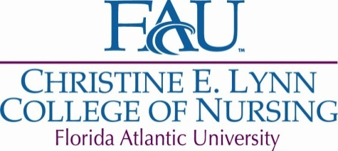

**2011-2012 Annual Report for the PhD Program**

Admissions

Ten PhD students were admitted in the past academic year (five students started the spring 2012 semester and five students will start in the fall). One of the fall students had previously attended at FAU but moved away. One student is BSN-PhD.

Recruitment

Dr. Liehr and Kristine Killip had individual meetings with 20 prospective students from November, 2011 to May, 2012. Five of these students applied and were accepted to the program. Kristine Killip attended graduate open house/recruitment events at FAU and has made contact with approximately 40 prospective PhD students through email and telephone.

Progression

Two PhD students graduated this academic year: Louise Lucas (December, 2011) and Bridgette Johnson (May, 2012)

The following PhD students passed comprehensive exams: F. Onyejurawa (fall, 2011), K. Grimley (spring, 2012).

Five PhD students completed their dissertation proposal hearings during the spring 2012 semester: K. White, E. Millender, K. Arnold, and F. Onyejuruwa, and S. Greif.

Two PhD students have discontinued their studies: B. Blanco and N. Palmer.

PhD Program improvements: Policies and procedures have been reviewed over the course of the year. The 90 hour research practicum guidelines were updated and approved by the PhD committee. The PhD information contained in the College of Nursing Graduate Student Handbook was updated and reviewed at the PhD Faculty Retreat.

PhD Grants

Graduate College Recruitment Grant: The PhD program was awarded one Presidential Fellowship and $2,000 of recruitment funding. The Presidential Fellowship will be awarded to Christine Moffa, beginning in the fall 2012 semester.

Jonas Nurse Leaders Scholar Program: The College received a $10,000 grant by the Jonas Center for Nursing Excellence. The selected scholar is Susan Driscoll, who was admitted to the PhD program for the spring 2012 semester.

Dissertation year Grants: Two PhD students submitted grant applications to the Division of Research. Award notification has not yet occurred.

The GAANN grant second year report was completed and submitted in April to ensure funding for the third year.

Conference Attendance

South Florida Nursing Research Conference: Seven PhD students attended this conference in October, with one student participating in the poster session and two students presenting abstracts.

Southern Nursing Research Society: Five students attended and four PhD students presented posters at the 2012 annual conference in February.

Curriculum

Several course syllabi were reviewed and refined over the course of the academic year: NGR 7932, NGR 7934, NGR 7936, and NGR 6930 (doctoral level Statistics). The doctoral level Statistics course received University approval and will be offered in the fall 2012 semester as: NGR 7481: Essential Statistical Methods for Nursing Science.

Miscellaneous

The annual PhD faculty retreat was held May 14, 2012.

Following a suggestion to have doctoral students join the PhD committee meetings, Beth Pratt, Linda Cassidy, and Shirley Eckes began attending committee meetings effective October 31st, 2011.